VISVESVARAYA TECHNOLOGICAL UNIVERSITY JNANA SANGAMA, BELAGAVI

# An Internship Report

***On***

## Chamundeshwari Electrical Supply Corporation Limited Mysore, HINKAL

***Submitted in partial fulfillment for the award of the degree of***

## BACHELOR OF ENGINEERING

**In**

## ELECTRICAL & ELECTRONICS ENGINEERING

***Submitted By***

## AISHWARYA R (4GW19EE002)

**Internship Carried At CESCOM, MYSORE**

|  |  |
| --- | --- |
| Internal Guide  **Dr. Jagadisha N** Associate Professor EEE Department | External Guide  **Subash G** Assistant GM CESC, MYSORE |

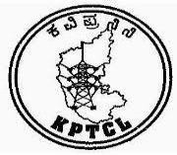

## DEPARTMENT OF ELECTRICAL & ELECTRONICS ENGINEERING

***GSSS INSTITUTE OF ENGINEERING & TECHNOLOGY FOR WOMEN***

### Affiliated To Visvesvaraya Technological University, Belagavi Approved By All India Council

**for Technical Education, New Delhi**

### K.R.S. Road Metagalli, Mysuru – 570 016

Accredited by NBA, New Delhi (Validity: 01.07.2017 - 30.06.2020)

Geetha Shishu Shikshana Sangha (R )

**GSSS INSTITUTE OF ENGINEERING & TECHNOLOGY FOR WOMEN**

(Affiliated to VTU, Belagavi, Approved by AICTE -New Delhi & Govt. of Karnataka)

*K.R.S Road, Mysuru-570016, Karnataka*

**DEPARTMENT OF ELECTRICAL & ELECTRONICS ENGINEERING**

(Accredited by NBA, New Delhi, Validity 01.07.2017 to 30.06.2020)



## CERTIFICATE

Certified that the 8th Semester Internship titled **“Chamundeshwari Electrical Supply Corporation Limited Mysore**” is a bonafide work carried out by **Aishwarya R (4GW19EE002)** in partial fulfillment for the award of degree of bachelor of engineering in **Department Engineering** of the Visvesvaraya Technological University, Belagavi, during the year 2018-19. The internship report has been approved as it satisfies the academic requirements with respect to the Internship work prescribed for Bachelor of Engineering Degree.

|  |  |  |
| --- | --- | --- |
| **…………………………..**  **Signature of Guide (Dr. Jagadisha N)** | **………………………….**  **Signature of HOD**  **(Dr. G Sreeramulu Mahesh )** | **…………………………… Signature of Principal (Dr. M Shivakumar )** |

### External Viva

|  |  |
| --- | --- |
| **Name of Examiners**  **1.**  **2.** | **Signature with Date** |

ACKNOWLEDGEMENT

The joy and satisfaction that accompany the successful completion of any task would be incomplete without the mention of the people who made it possible.

First and foremost, we offer our sincere phrases of thanks to **Smt. Vanaja B Pandit,** Hon. Secretary, GSSSIETW and the management of GSSSIETW, Mysuru for providing help and support to carry out the internship.

I would like to express our gratitude to our Principal, **Dr. Shivakumar M** for providing me a congenial environment for engineering studies and also for having showed me the way to carry out the seminar.

I consider it a privilege and honour to express our sincere thanks to my guide **Dr .G Sreeramulu Mahesh** Professor and Head, Department of Electrical & Electronics Engineering for his support, invaluable guidance, motivation, encouragement for the successful completion of seminar.

I intend to thank all the teaching and non-teaching staffs of our Department of Electrical & Electronics Engineering for their immense help and co-operation.

Finally, I would like to express my gratitude to my parents and friends who always stood by me.

Thank you.

**AISHWARYA R (4GW19EE002)**

# TABLE OF CONTENTS

|  |  |  |
| --- | --- | --- |
| **Sl No.** | **Description** | **Page No.** |
| **1.** | **Chapter 1 : CESCOM**   * 1. About   2. Evolution of Electricity in Mysuru   3. Function of CESCOM   4. Existing infrastructure and performance | **1 – 4**  1 – 2  2 – 3  3 – 4  4 |
| **2.** | **Chapter 2 : BACKGROUND**   * 1. Need of Electricity   2. A brief note on Electric power generation | **5**  5  5 |
| **3.** | **Chapter 3 : Transmission and Distribution**   * 1. Introduction of Transmission and Distribution   2. Components of distribution in power supply   3. Types of Transmission in Power Supply   4. Transmission Lines | **6 – 9**  6  7  7 – 8  8 – 9 |
| **4.** | **Chapter 4 : Substation Visit**   * 1. Electrical Substation   2. Elements of Substation   3. Corona Effect, Skin Effect & Ferrenti Effect in Substation   4. Line Diagram   5. Components in Electrical Substation | **10 – 24**  10 – 11  12  13 – 14  14 – 15  15 – 24 |
| **5.** | **Chapter 5 : Conclusion** | **25 – 26** |

**CHAPTER-01 CESCOM**

## ABOUT

Chamundeshwari Electricity Supply Corporation Limited (CESC) is an Indian electricity distribution company that serves the districts of Mysore, Mandya, Chamarajanagara, Hassan and Kodagu in the state of Karnataka. It was established in 2002 as a result of the restructuring of the Karnataka Electricity Board (KEB), which was responsible for the generation, transmission and distribution of electricity in the state. The CESC is responsible for the distribution of electricity to over 25 lakh consumers in its service area.The CESC is headquartered in Mysore and has its regional offices in Mandya, Chamarajanagar, Hassan and Kodagu. The company is responsible for the distribution of electricity to both rural and urban areas in its service area. The CESC is also responsible for the maintenance of the electricity distribution network, which includes the operation and maintenance of the sub-stations, transmission lines, distribution lines and transformers.The CESC is a government-owned company and is managed by a board of directors. The board of directors is responsible for the overall management of the company and is appointed by the government of Karnataka. The managing director of the company is responsible for the day-to-day operations of the company.The CESC has a total installed capacity of 1,395 MW, which includes both thermal and hydro power plants. The company also procures power from other sources to meet the electricity demand in its service area. The company is also responsible for the implementation of various energy conservation measures to reduce the demand for electricity in its service area.The CESC has implemented various measures to improve the quality of electricity supply in its service area. The company has implemented a SCADA (Supervisory Control and Data Acquisition) system to monitor and control the distribution network. The SCADA system helps the company to detect faults and restore power supply quickly in case of any disruptions.The CESC has also implemented a customer service portal, which allows consumers to pay their electricity bills online, view their billing history and lodge complaints. The company has also set up a call center to provide assistance to consumers.The CESC has implemented various measures to promote renewable energy in its service area. The company has set up a solar power plant with a capacity of 200 kWp in Mysore. The company has also implemented a net metering system, which allows consumers to generate electricity from solar panels and sell the

excess power to the grid.The CESC has also implemented various measures to improve the efficiency of the electricity distribution network. The company has implemented a smart metering system, which allows the company to monitor the electricity consumption of consumers in real-time. The smart metering system also helps the company to detect electricity theft and reduce distribution losses.In conclusion, Chamundeshwari Electricity Supply Corporation Limited is an important electricity distribution company in the state of Karnataka, India. The company is responsible for the distribution of electricity to over 25 lakh consumers in its service area. The company has implemented various measures to improve the quality of electricity supply, promote renewable energy and improve the efficiency of the electricity distribution network. The CESC plays an important role in ensuring the availability of reliable and affordable electricity to the people of Karnataka.

## EVOLUTION OF ELECTRICITY IN MYSURU :

Mysuru (also known as Mysore) is a city in the state of Karnataka, India. The history of electricity in Mysuru dates back to the early 20th century when the city was ruled by the Wodeyar dynasty.

In 1902, the Wodeyar rulers established the Mysore Power Supply Company to provide electricity to the city. The company built a hydroelectric power plant at Shivanasamudra, about

80 km from Mysuru, to generate electricity. The power generated from this plant was transmitted to Mysuru through overhead transmission lines.

In 1920, the Mysore Power Supply Company was taken over by the government of Mysore, and the Mysore State Electricity Board (MSEB) was established to manage the power supply in the state. The MSEB started expanding the power supply network in Mysuru and other parts of the state.

In the 1960s, the MSEB started building thermal power plants to meet the increasing demand for electricity. The first thermal power plant was built at Raichur, about 350 km from Mysuru. The power generated from this plant was transmitted to Mysuru through a high- voltage transmission line.

In the 1980s, the MSEB started building more thermal power plants in the state, including the Bellary Thermal Power Station and the Yelahanka Thermal Power Station. These plants helped to meet the increasing demand for electricity in Mysuru and other parts of the state.

In the 1990s, the government of Karnataka established the Karnataka Power Transmission Corporation Limited (KPTCL) to manage the transmission and distribution of electricity in the state. KPTCL took over the transmission and distribution network from MSEB, which was later renamed Karnataka Power Transmission Corporation Limited (KPTCL). Today, Mysuru gets its electricity from a mix of sources, including hydroelectric power, thermal power, and renewable sources such as wind and solar power. The city has a well developed electricity transmission and distribution network, which ensures reliable power supply to its residents and businesses.



Fig .1.1

## FUNCTION OF THE CESCOM :

CESCOM (Centralised Selection Committee) is a recruitment agency that conducts selection processes for various government departments and agencies in the state of Karnataka, India. The primary function of CESCOM is to facilitate the recruitment of eligible candidates for various government positions by conducting fair and transparent selection processes.

Some of the key functions of CESCOM are:

Issuing notifications and advertising vacancies: CESCOM issues notifications and advertises vacancies in various government departments and agencies. These notifications contain all the necessary details about the vacancies, such as eligibility criteria, educational qualifications, age limit, and selection process. Receiving and scrutinizing applications: CESCOM receives and scrutinizes applications from candidates who apply for the advertised vacancies. The applications are checked for eligibility, completeness, and accuracy Conducting selection processes: CESCOM conducts selection processes such as written tests, interviews, and physical tests to shortlist candidates for the vacancies. These selection processes are

conducted in a fair and transparent manner to ensure that the best candidates are selected for the positions. Finalizing the selection and issuing appointment orders: CESCOM finalizes the selection ofcandidates based on their performance in the selection processes and issues appointment orders to the selected candidates. Overall, the function of CESCOM is to ensure that the recruitment process for government positions is transparent, fair, and merit-based.

## EXISTING INFRASTRUCTURE AND PERFORMANCE:

Existing infrastructure and performance of power supply in mysuru. As an AI language model, I don't have access to real-time data or information about the current state of infrastructure and power supply in Mysuru. However, I can provide you with some general information about the power supply situation in India and Mysuru. In India, the power sectoris mainly divided into three categories: Generation, Transmission, and Distribution. The Central Government is responsible for generation and transmission of electricity while the State Governments are responsible for distribution.

Mysuru comes under the jurisdiction of the Chamundeshwari Electricity Supply Corporation (CESC), which is responsible for the distribution of electricity in the region. The performance of power supply in Mysuru depends on various factors such as demand, capacity, infrastructure, maintenance, and weather conditions. The Government of India has initiated various schemes such as UDAY (Ujwal DISCOM Assurance Yojana) to improve the financial and operational efficiency of power distribution companies. The CESC has also implemented various measures to improve the power supply situation in Mysuru.

In recent years, there have been efforts to promote renewable energy sources such as solar and wind energy in India, which can help to reduce the dependency on traditional sources of electricity and improve the reliability of the power supply.Overall, the power supply situation in Mysuru may vary depending on the specific location and time. It's best to check with the local electricity department or authorities for the most up-to-date information.

# CHAPTER-02 BACKGROUND

**2.1 NEED OF ELECTRICITY:**

Electricity is an essential part of modern life, and it plays a crucial role in many aspects of our daily routines. Here are some of the reasons why electricity is so important:

Powering homes and businesses: Electricity is essential for powering homes and businesses, from lighting and heating to running appliances and operating machinery.

Communication: Electricity is necessary for communication technologies such as phones, computers, and the internet.

Transportation: Electricity is increasingly important in transportation, as electric vehicles become more common and cities expand public transportation systems.

Healthcare: Many medical devices, including life-support systems, require electricity to function.

Entertainment: Television, music systems, gaming consoles, and other forms of entertainment all rely on electricity.

Manufacturing: Electricity is used to power many manufacturing processes, from food production to electronics assembly.

Overall, electricity is essential to our modern way of life, and it is hard to imagine a world without it .

## 2.2. A BRIEF NOTE ON ELECTRIC POWER GENERATION

Electric power generation refers to the process of producing electricity from various sources of energy, such as fossil fuels, nuclear power, and renewable sources like wind, solar, hydro, and geothermal.The most common method of electricity generation involves the conversion of mechanical energy into electrical energy using generators. These generators are typically driven by steam turbines, which are powered by heat generated from burning fuels, nuclear reactions, or harnessing the kinetic energy of falling water. In recent years, there has been a growing emphasis on the use of renewable energy sources to generate electricity, as they are more sustainable and have a lower environmental impact compared to fossil fuels. Renewable energy sources are expected to play a more significant role in future electricity generation as technology continues to improve and costs decrease.

# CHAPTER -3 TRANSMISSION AND DISTRIBUTION

## INTRODUCTION OF TRANSMISSION AND DISTRIBUTION :

Transmission and distribution are two crucial components of the electrical power system that enable the efficient and reliable supply of electricity to consumers.Transmission refers to the movement of high-voltage electrical power over long distances, typically from power plants to distribution substations located closer to the point of use. This is achieved through the use of high-voltage power lines, which can transmit large amounts of electricity over long distances with minimal losses.

Distribution, on the other hand, involves the delivery of lower-voltage electrical power from distribution substations to homes, businesses, and other end-users. This is typically accomplished through a network of distribution lines and transformers, which step down the voltage of the electricity to levels suitable for use by consumers.Both transmission and distribution systems are critical to the functioning of modern society, as they enable the reliable and efficient delivery of electricity for a wide range of applications, from lighting and heating to industrial processes and transportation.

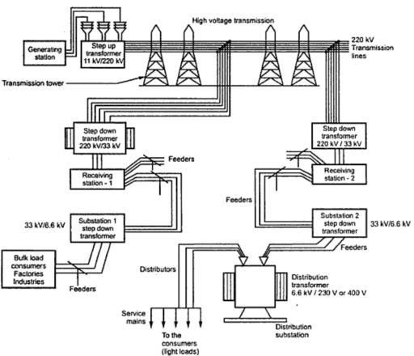

Fig. 3.1 Schematic representation of a typical transmission distribution scheme

## COMPONENTS OF DISTRIBUTION IN POWER SUPPLY:

In a power supply system, the distribution component refers to the stage where the power is transmitted from the main substation to the end-users through a network of power lines and transformers. The distribution system typically consists of several components, including:

Substations: Substations are facilities that receive high voltage power from the transmission lines and transform it into lower voltage levels that are suitable for distribution to consumers. Substations may also include equipment for controlling and protecting the power system.

Distribution Lines: These are the power lines that carry the power from the substation to the end-users. The distribution lines are usually divided into primary and secondary lines. Primary lines carry higher voltages and are used to transmit power over longer distances, while secondary lines carry lower voltages and are used to distribute power to homes and businesses. Transformers: Transformers are used to step down the voltage of the power before it is distributed to consumers. They are located at various points along the distribution lines to

ensure that the voltage is appropriate for the equipment being used.

Switchgear: Switchgear is equipment used to control the flow of power in the distribution system. It includes devices such as circuit breakers, disconnect switches, and fuses, which are used to protect the system from overloads and faults.

Meters: Meters are used to measure the amount of electricity consumed by the end- users. They are typically located at the customer's premises and are used to determine the amount of electricity consumed for billing purposes.

Overall, the distribution system plays a critical role in ensuring that electricity is delivered reliably and efficiently to end-users.

## TYPES OF TRANSMISSION IN POWER SUPPLY :

There are two main types of transmission in power supply:

AC (alternating current) transmission - this is the most common type of transmission in power systems. AC is used because it can be easily transformed to different voltages using transformers, which enables power to be transmitted over long distances with minimal loss.

AC transmission is also more efficient than DC (direct current) transmission for most applications.

DC (direct current) transmission - this type of transmission is becoming more popular for certain applications, such as high-voltage, long-distance transmission and for connecting renewable energy sources to the grid. DC transmission has lower losses than AC transmission over long distances, and it can also help to improve the stability of the power system. However, DC transmission requires more complex equipment, such as converters, to convert AC to DC and vice versa.

## TRANSMISSION LINES:

A transmission line is a type of cable or conductor that is used to transmit electrical energy or signals from one point to another, typically over long distances. Transmission lines are used in a variety of applications, including power transmission, telecommunications, and data communications.

In power transmission, transmission lines are used to transport electrical power from power plants to substations, where it is then distributed to customers. The most common types of transmission lines used for power transmission are overhead lines, which are typically made of aluminum or steel and supported by towers or poles, and underground lines, which are buried in the ground and typically made of insulated cables.

In telecommunications and data communications, transmission lines are used to transmit signals between devices, such as telephones, computers, and other electronic devices. These lines are typically made of coaxial cable, twisted-pair cable, or fiber-optic cable, and are designed to minimize signal loss and interference.

The performance of a transmission line is influenced by its physical characteristics, including its length, cross-sectional area, and the materials used to construct it. The characteristics of the signal being transmitted, such as frequency, amplitude, and phase, also play a role in determining the performance of the line.

Transmission lines are an important component of modern infrastructure, enabling the efficient and reliable transmission of electrical energy and signals over long distances.

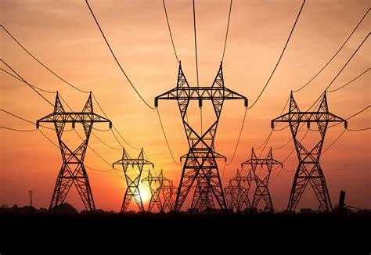

Fig. 3.2 Transmission lines

# CHAPTER -4 SUBSTATION VISIT

## ELECTRICAL SUBSTATION:

An electric substation is an integral part of an electrical power system. It is a facility that connects and distributes electrical power from generating stations to customers. It is an important link between the high-voltage transmission system and the low-voltage distribution system. The substation plays a vital role in ensuring the reliability, safety, and efficiency of the electrical power system.The purpose of an electric substation is to receive electrical power from one or more generating stations and distribute it to different regions or locations. The electrical power is usually transmitted at very high voltages, such as 345 kV, 500 kV, or 765 kV, over long distances through high-voltage transmission lines. These high-voltage transmission lines are connected to the substation, which steps down the voltage to a lower level, such as 69 kV or 138 kV. This lower voltage is then distributed to different areas through the low-voltage distribution lines.

Electric substations consist of various components that work together to ensure the proper functioning of the electrical power system. Some of the main components of an electric substation include transformers, circuit breakers, switches, capacitors, and reactors.

* + - Transformers are the most important components of a substation. They are used to step up or step down the voltage of the electrical power that is being transmitted. Step-up transformers increase the voltage from the generating station to the transmission voltage level, while step-down transformers decrease the voltage from the transmission level to the distribution level.
    - Circuit breakers are used to interrupt the flow of electrical current in the event of a fault or overload. They protect the electrical power system from damage and ensure the safety of the substation personnel.
    - Switches are used to control the flow of electrical power through the substation. They are used to isolate or connect different parts of the electrical power system, and they help to redirect the electrical power in case of an emergency.
    - Capacitors are used to improve the efficiency of the electrical power system. They store electrical energy and release it when needed, which helps to regulate the voltage and stabilize the electrical power system.
    - Reactors are used to regulate the flow of electrical current in the transmission lines. They are used to control the voltage and protect the electrical power system from overloads.
    - Electric substations are classified into different types based on their function and design. Some of the main types of electric substations include transmission substations, distribution substations, switching substations, and converter substations.
    - Transmission substations are used to step up or step down the voltage of the electrical power being transmitted. They are usually located near the generating stations and are connected to the high-voltage transmission lines.
    - Distribution substations are used to distribute the electrical power to different regions or locations. They are usually located near the load centers and are connected to the low-voltage distribution lines.
    - Switching substations are used to connect or disconnect different parts of the electrical power system. They are usually located at strategic points in the transmission or distribution system and are used to redirect the flow of electrical power in case of an emergency.
    - Converter substations are used to convert the electrical power from one form to another. They are usually located at the interconnection points between different power systems, such as AC-DC converter stations or DC-AC inverter stations.
    - In conclusion, electric substations are essential components of the electrical power system. They play a crucial role in ensuring the reliability, safety, and efficiency of the electrical power system. They consist of various components that work together to receive, distribute, and regulate the flow of electrical power. The different types of electric substations have different functions and designs, but they all contribute to the proper functioning of the electrical power system.

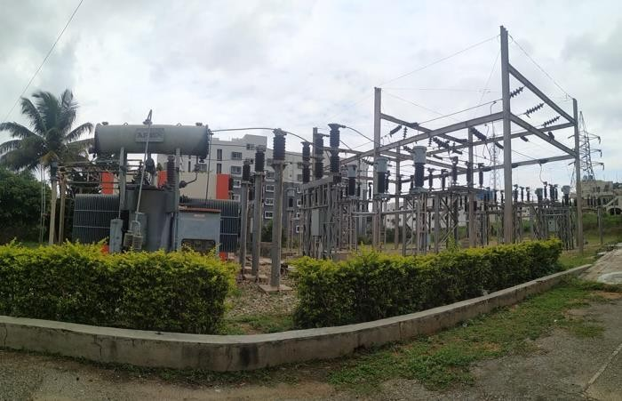

Fig. 4.1 Substation

## ELEMENTS OF SUBSTATION:

A substation is an integral part of an electrical power system that plays a crucial role in transforming and distributing electric power to end-users. The primary elements of a substation include:

Transformers: These are devices that are used to step up or step down the voltage of electric power for efficient distribution and transmission over long distances.

Circuit breakers: These are safety devices that protect electrical equipment from damage caused by overloading or short circuits. They automatically cut off the power supply in case of any faults.

Busbars: These are metallic bars that carry the electric power from the transformers to the different distribution points.

Switchgear: These are devices used to control and isolate different sections of the electrical system. They are used to manage the flow of electricity and protect the equipment from damage caused by overloads or short circuits.

Protection relays: These are devices used to detect any abnormalities in the electrical system and activate the circuit breakers to prevent damage.

Control systems: These are devices used to control the power flow and monitor the performance of the substation.

Lightning arrestors: These are devices used to protect the substation equipment from lightning strikes.

Batteries and chargers: These are backup systems used to ensure uninterrupted power supply to critical equipment during power outages.

Grounding systems: These are systems used to protect the substation equipment and personnel from the dangers of electrical faults and lightning strikes.

Communication equipment: These are devices used to monitor and control the substation remotely. They are also used to communicate with other parts of the electrical system.

## CORONA EFFECT,SKIN EFFECT AND FERRENTI EFFECT IN SUBSTATION:

The corona effect, skin effect, and Ferranti effect are three distinct phenomena that occur in electrical power systems. These effects are all related to the behavior of electricity in high-voltage power transmission lines.

**Corona Effect :** The corona effect is a phenomenon that occurs in high voltage transmission lines. When the voltage of a power line is very high, the air around the conductor can become ionized. This ionization can cause a glow around the conductor, which is known as a corona discharge. The corona effect can result in energy loss, as well as the production of noise and electromagnetic interference. In extreme cases, the corona effect can cause damage to the power line, and it can also be dangerous for people in the vicinity of the line.To mitigate the corona effect, power companies use specially designed transmission lines that have a smooth surface and a rounded shape. These lines are also spaced farther apart than regular power lines. This design reduces the likelihood of ionization and corona discharge.

**Skin Effect :** The skin effect is a phenomenon that occurs in high-frequency alternating current (AC) power transmission lines. When the frequency of the AC power is very high, the current tends to flow more towards the outer surface of the conductor. This is due to the interaction between the current and the magnetic field created by the current. The result is that the effective cross-sectional area of the conductor is reduced, and the resistance of the conductor increases. This increase in resistance can cause energy loss in the power transmission line.To mitigate the skin effect, power companies use conductors that are made of multiple strands of wire. This design increases the surface area of the conductor, reducing the impact of the skin effect. Another technique is to use hollow conductors that have a larger surface area than solid conductors.

**Ferranti Effect :** The Ferranti effect is a phenomenon that occurs in long high voltage power transmission lines. When power is transmitted over long distances, the voltage at the receiving end of the line can be higher than the voltage at the sending end. This is due to the capacitance of the transmission line, which causes a voltage drop along the length of the line. The result is that the voltage at the receiving end of the line can be higher than the voltage at the sending end, which can cause damage to electrical equipment.To mitigate the Ferranti effect, power companies use voltage regulation devices such as transformers and capacitors. These devices are designed to regulate the voltage of the power as it is transmitted over long distances, reducing the impact of the capacitance of the transmission line. In conclusion, the

corona effect, skin effect, and Ferranti effect are all phenomena that occur in electrical power systems. These effects can cause energy loss, damage to equipment, and electromagnetic interference. To mitigate these effects, power companies use specialized transmission lines, conductors, and voltage regulation devices. Understanding these effects is important for ensuring the safe and efficient operation of electrical power systems.

## SINGLE LINE DIAGRAM:

A single line diagram (SLD) is a graphical representation of the electrical distribution system of a substation. It shows the main components of the system, such as transformers, circuit breakers, disconnect switches, and other equipment, as well as the interconnections between them.The purpose of an SLD is to provide a clear and concise overview of the substation's electrical system, enabling engineers and technicians to quickly understand the system's configuration and troubleshoot problems. The SLD also shows the direction of power flow and the protection schemes used to safeguard the equipment and personnel.

Some common elements shown on an SLD include:

* + - Primary and secondary distribution lines
    - Transformer and transformer connections
    - Circuit breakers and disconnect switches
    - Busbars and busbar connections
    - Protective relays and associated equipment
    - Grounding system and lightning protection
    - Metering and control equipment

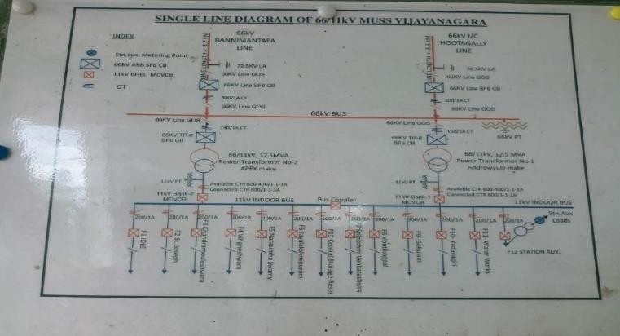SLDs can be created using specialized software, such as AutoCAD or MicroStation, or by hand. They are typically included in substation design documents and used as a reference during construction and maintenance.

Fig. 4.2 Single line diagram

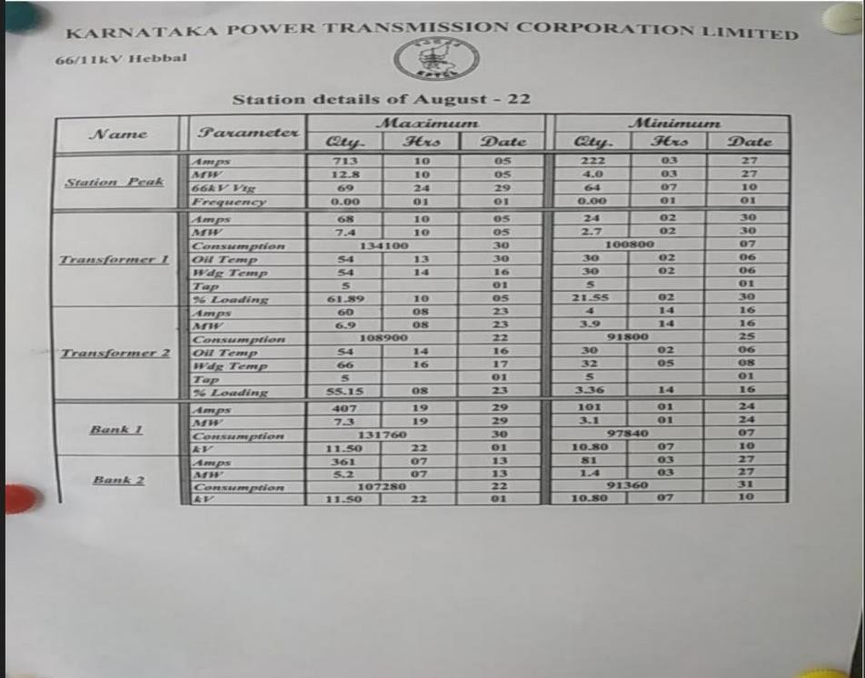

Fig. 4.3 Station details

## COMPONENTS IN ELECTRICAL SUBSTATION:

### LIGHTNING ARRESTERS

Lightning arresters are devices used to protect electrical equipment and buildings from the damaging effects of lightning strikes. Lightning is a powerful electrical discharge that can occur during thunderstorms, and can carry millions of volts of electrical energy. If lightning strikes a building or electrical equipment, it can cause significant damage, including fires, explosions, and electrical surges that can damage or destroy equipment. A lightning arrester works by providing a low-impedance path for the lightning current to flow through, instead of passing through the equipment or building. This is achieved by using a device that is designed to conduct electricity very well, such as a metal rod or wire. The lightning arrester is typically installed on the roof of a building or near electrical equipment, and is connected to the ground via a wire or cable.

When lightning strikes, the arrester provides a path of least resistance for the lightning current to travel to the ground. The current flows through the arrester and into the ground, protecting the equipment or building from damage. The arrester may also include a surge diverter, which is a device that can help to reduce the voltage surge that can occur during a lightning strike.Lightning arresters are typically used in high-voltage electrical systems, such

as power transmission lines and substations, as well as in residential and commercial buildings that are at risk of lightning strikes. They are an important safety feature that can help to prevent.

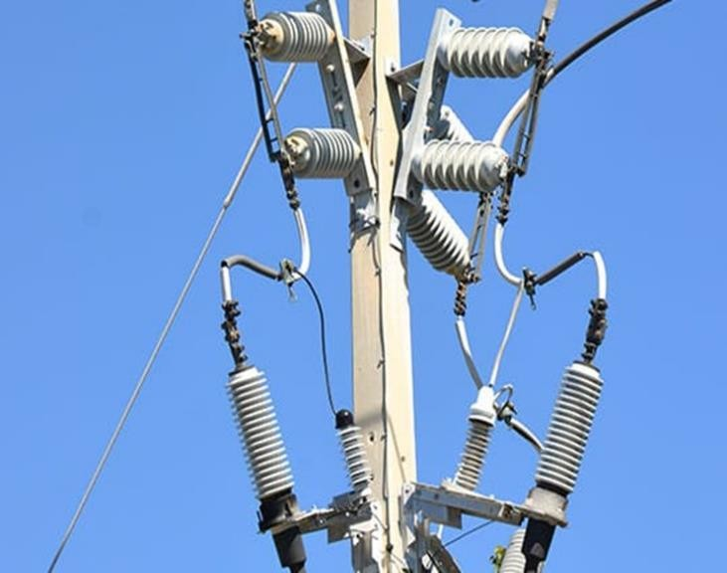

Fig. 4.4 Lightning arrester

### WAVE TRAPPER IN SUBSTATION :

A wave trapper is a device used in substations to prevent high-frequency transient voltage surges, also known as voltage transients or voltage spikes, from damaging electrical equipment. These surges can occur due to lightning strikes, switching operations, or other causes and can potentially cause damage to sensitive equipment such as transformers, circuit breakers, and relays.

Wave trappers work by diverting the high-frequency transient voltage surges to ground, using a low-pass filter circuit. The circuit is designed to allow only low-frequency signals to pass through, while high-frequency signals are blocked and diverted to ground. By doing so, the wave trapper protects the electrical equipment from the damaging effects of the voltage surges. In addition to wave trappers, other protective measures such as lightning arrestors and surge arrestors may also be used in substations to protect against transient voltage surges. These protective devices are important for maintaining the reliability and safety of electrical systems.

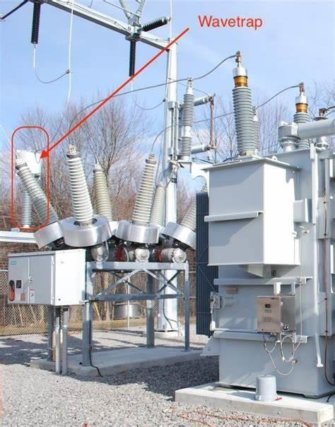

Fig. 4.5 Wavetrap

### Current Transformer:

A current transformer is a type of transformer that is used to measure the current flowing through an electrical conductor without actually having to come into direct contact with it. It works by inducing a current in a secondary winding that is proportional to the current in the primary winding (the conductor being measured).

The primary winding of a current transformer consists of a single turn or a few turns of a thick conductor, while the secondary winding typically consists of many turns of a fine conductor. The primary winding is connected in series with the conductor carrying the current that needs to be measured, while the secondary winding is connected to a measuring instrument or a protective relay. Current transformers are used in a wide range of applications, including power systems, electrical meters, and protective relays. They are particularly useful for measuring high currents, such as those found in power transmission and distribution systems, where it is impractical or unsafe to directly measure the current. Current transformers can also be designed to provide galvanic isolation between the primary and secondary circuits, which can help to improve safety and reduce noise and interference.

### POTENTIAL TRANSFORMER:

A potential transformer (PT) is a type of instrument transformer used to step down high voltage power to a lower level that is suitable for measurement or control purposes. It is commonly used in electrical power systems to provide accurate and reliable voltage

measurement for protective relaying, metering, and control equipment. The PT operates on the principle of electromagnetic induction, just like a standard transformer. However, the primary winding of a PT is connected in parallel to the high voltage line, and the secondary winding is connected to the measuring or control device. The secondary voltage is proportional to the primary voltage and is typically in the range of a few hundred volts, depending on the ratio of the transformer.

The main advantage of using a potential transformer is that it provides a safe and convenient means of measuring high voltage power, as the secondary voltage is isolated from the high voltage line. This allows for accurate measurement without the risk of electric shock or damage to the measuring equipment. Potential transformers come in a variety of sizes and voltage ratios, and they are often used in combination with current transformers (CTs) to provide comprehensive protection and monitoring of power systems.

### GROUP OPERATING SYSTEM IN SUBSTATION:

A group operating system (GOS) in a substation refers to the software or system that allows multiple devices or equipment within the substation to work together in a coordinated manner.In a substation, there are various devices, such as transformers, circuit breakers, relays, meters, and control systems, that need to work together to ensure that the power system operates safely and efficiently. The GOS is responsible for coordinating the activities of these devices, ensuring that they work together seamlessly, and providing a unified interface for operators to manage the substation.

The GOS typically includes a range of functions, such as:

Monitoring and control: The GOS provides a centralized system for monitoring the various devices within the substation and controlling their operation. This includes functions such as switching devices on and off, adjusting settings, and issuing commands

Protection and coordination: The GOS is responsible for ensuring that the protection devices within the substation operate correctly and that there is coordination between them to prevent any malfunctions

Data management: The GOS collects and stores data from various devices within the substation, which is used for monitoring, analysis, and decision-making purposes.

Communication: The GOS provides a communication network for the various devices within the substation, allowing them to exchange data and commands in a timely and reliable manner.

Overall, the group operating system plays a critical role in ensuring the safe and efficient operation of a substation. It provides a centralized platform for managing the various devices within the substation, improving reliability, and reducing the risk of equipment failure or other operational issues.

### CIRCUIT BREAKERS:

Circuit breakers are electrical switches designed to automatically interrupt electrical circuits in the event of an overload or short circuit. The primary function of a circuit breaker is to protect an electrical system from damage caused by excessive current flow. When the current flowing through a circuit exceeds the maximum safe level, the circuit breaker detects the overcurrent and trips, interrupting the flow of electricity. This helps prevent damage to electrical equipment, fires, and other hazards associated with electrical overloads .Circuit breakers are commonly used in residential, commercial, and industrial settings. They come in different sizes and ratings, depending on the application and the amount of current they are designed to handle. Some circuit breakers are designed to trip automatically when an overload is detected, while others can be manually reset after tripping. Overall, circuit breakers play a crucial role in ensuring the safety and reliability of electrical systems by protecting them from damage caused by overcurrent conditions.

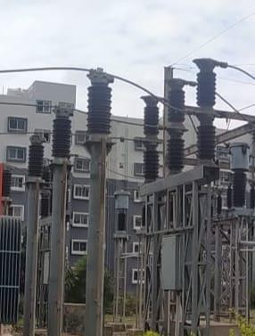

Fig. 4.6 Circuit breaker

### BATTERIES IN SUBSTATION:

Batteries are an important component in substation systems, particularly in providing backup power and ensuring the reliability and stability of the power grid. In a substation, batteries are typically used to provide a source of DC power for various applications, including: Emergency backup power: In the event of a power outage, batteries can provide a reliable source of backup power to critical systems, such as control and communication systems, to

ensure that the substation remains operational.

Voltage regulation: Batteries can be used in conjunction with voltage regulators to stabilize the voltage of the power grid and maintain a consistent level of power supply.

Switching operations: Batteries can be used to power the control circuits of switches, which allows for the safe and reliable operation of the switch.

Protection systems: Batteries can be used to power protective relays and other systems that monitor the substation and detect faults or abnormalities in the power grid.

Overall, batteries play a crucial role in maintaining the reliability and stability of the power grid, and are an essential component in modern substation systems.

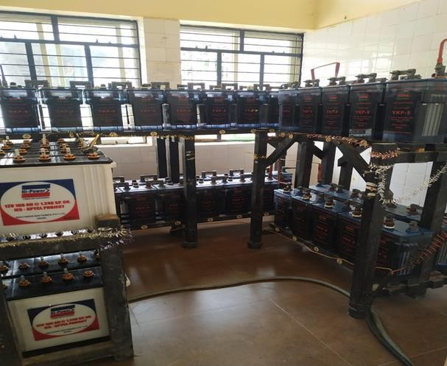

Fig. 4.7 Batteries

### TRANSFORMER IN SUBSTATION:

A transformer is a key component of an electrical substation. It is a device that is used to transfer electrical energy from one circuit to another through electromagnetic induction. In a substation, a transformer is used to step-up or step-down the voltage level of the electrical power being transmitted.The basic function of a transformer in a substation is to convert high- voltage, low-current power into low-voltage, high-current power, or vice versa. This is necessary because the power generated at the power station is usually at a high voltage, which is not suitable for long-distance transmission. Therefore, the voltage level is stepped up using a transformer to reduce energy losses during transmission. At the receiving end, the voltage is stepped down to a lower level, which is suitable for distribution to consumers.

Transformers in a substation are typically large, stationary devices that are housed in a dedicated building or structure. They are designed to handle high voltages and currents and are constructed using materials that can withstand these conditions. The design and construction of transformers in a substation must comply with strict safety standards and regulations to ensure the safe and reliable operation of the power grid.

In summary, a transformer in a substation is a crucial component that plays a key role in the distribution and transmission of electrical power. It allows power to be transmitted efficiently and safely over long distances, making it an essential part of modern electrical infrastructure.

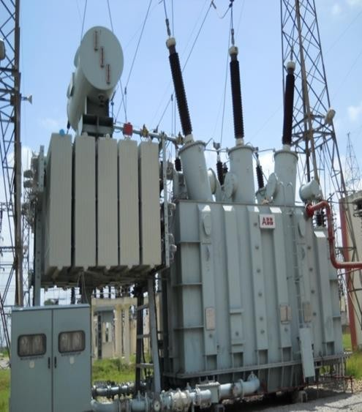

Fig. 4.8 Transformer

### SWITCH YARD IN SUBSTATION :

A switchyard is an important part of an electrical substation where high voltage electricity is transformed, transmitted, and distributed. It is an area within the substation where multiple power lines are connected to each other, and where switches, breakers, transformers, and other electrical equipment are installed.

In a typical switchyard, power lines from different sources, such as generators, transformers, or transmission lines, are connected together. The switchyard also contains various types of switches, including isolators, circuit breakers, and earth switches. These switches are used to control the flow of electricity and to isolate faulty equipment in case of a fault.

Transformers are another important component of a switchyard. They are used to step down the high voltage electricity to a lower voltage, which is suitable for distribution to homes and businesses. The switchyard may also include capacitors and reactors, which are used to control the voltage and current levels in the electrical system.

Overall, the switchyard is a crucial part of a substation, as it allows for the efficient and safe transmission and distribution of high voltage electricity. Proper maintenance and upkeep of the switchyard is essential to ensure the reliability and safety of the electrical system.

### PROTECTIVE EARTHING AND TRANSFORMER PROTECTION IN SUBSTATION:

Protective earthing and transformer protection are two important aspects of substation design that are critical for ensuring the safety of personnel and equipment, as well as the reliable operation of the power system.

Protective earthing is a technique used to ensure that all metal parts of an electrical installation are at the same electrical potential, which is typically earth potential. This is achieved by connecting all metal parts to a common earthing system. The purpose of protective earthing is to provide a safe path for electrical fault currents to flow, which prevents the formation of hazardous voltages that could harm personnel or damage equipment. In substation design, protective earthing is typically achieved through the use of a grounding grid or earth mat, which is a network of conductors buried in the soil around the substation.

Transformer protection is a set of measures used to protect transformers from damage due to faults or other abnormal conditions. Transformers are critical components of the power system that are used to step up or step down voltage levels. If a fault occurs in a transformer,

it can cause serious damage to the transformer and may even result in a complete failure of the transformer. To prevent this from happening, a number of protection schemes are used in substation design, including overcurrent protection, differential protection, and temperature monitoring. These protection schemes are typically implemented using protective relays, which are electronic devices that can detect abnormal conditions and initiate protective actions, such as tripping a circuit breaker to isolate the transformer from the rest of the system.

In summary, protective earthing and transformer protection are critical components of substation design that ensure the safe and reliable operation of the power system. Protective earthing provides a safe path for electrical fault currents, while transformer protection helps to prevent damage to transformers due to faults or abnormal conditions.

### 66/11kv SUBSTATION :

A 66/11kV substation is an electrical installation designed to transform the electrical power received from the transmission system at a voltage of 66kV into a lower voltage level of 11kV, which is suitable for distribution to end-users. The substation comprises various components and systems that work together to ensure reliable and safe distribution of electrical power.

The primary components of a 66/11kV substation include the incoming 66kV transmission line, the power transformer, and the outgoing 11kV distribution feeders. The incoming 66kV line brings in the high voltage electrical power from the transmission system and connects to the substation through a circuit breaker or a switchgear. The power transformer then steps down the voltage level from 66kV to 11kV, enabling it to be distributed to end-users.

The power transformer is one of the critical components of the substation, and it must be sized correctly to handle the electrical load demand. Transformers operate on the principle of electromagnetic induction and comprise two or more coils of wire. The primary coil of the transformer receives the 66kV high voltage electrical power, while the secondary coil outputs the stepped-down 11kV voltage.

The 11kV distribution feeders transmit the power from the transformer to the end users. The feeders are typically in the form of overhead lines or underground cables and are connected to the transformer through a switchgear. The switchgear provides isolation and protection against short-circuits and overloads that may occur within the distribution network.

In addition to the primary components, a 66/11kV substation also comprises auxiliary equipment such as the control and protection system, battery and charger system, and the

earthing system. The control and protection system monitors the electrical parameters of the substation, such as voltage, current, and frequency, and triggers alarms or trip signals when there is a fault or abnormal condition.

The battery and charger system provides backup power to critical systems such as the control and protection system and the emergency lighting system in the event of a power outage. The earthing system ensures that the substation and its equipment are adequately grounded to prevent electrical shocks and reduce the risk of electrical fires.

66/11kV substations are typically found in urban and industrial areas and are used to distribute electrical power to residential, commercial, and industrial customers. The substations are designed to operate efficiently and reliably, with high availability and low downtime. To ensure safe and efficient operation, regular maintenance Sand testing are necessary to identify and address potential faults and defects.

In summary, a 66/11kV substation is a critical component of the electrical power distribution network. It plays a vital role in stepping down the high voltage power received from the transmission system to a lower voltage level suitable for distribution to end-users. The substation comprises various components and systems that work together to ensure reliable and safe distribution of electrical power.

# CHAPTER 5 CONCLUSION

An electrical substation is an integral part of the power transmission and distribution system, responsible for transforming high voltage electricity from power plants into lower voltage electricity that can be used by homes and businesses. The substation plays a crucial role in the efficient and reliable supply of electricity, as it serves as a hub for power flow control, protection, and monitoring .Substations are typically composed of several components, including transformers, switchgear, circuit breakers, busbars, and protective devices. The transformers step down the voltage of the electricity, while the switchgear and circuit breakers are used to control the flow of electricity and protect the system from damage. Busbars are used to connect various components within the substation, while protective devices are used to monitor the system and trip the circuit breakers in case of faults.

One of the primary purposes of a substation is to ensure the efficient transmission of electricity. By transforming high voltage electricity into lower voltage electricity, the substation allows for the electricity to travel over long distances with minimal losses. The transformers used in substations are designed to reduce the voltage level of the electricity, which reduces the amount of current that flows through the transmission lines. This, in turn, reduces the losses associated with the resistance of the transmission lines.Another important function of the substation is to provide protection to the power system. The protective devices installed in the substation monitor the system for faults and are designed to trip the circuit breakers in case of overloads or short circuits. This helps to prevent damage to the equipment and ensure the safety of the operators working on the system.

Substations also play a vital role in ensuring the reliability of the power supply. By providing redundancy in the system, substations ensure that the power supply can be maintained even in the event of a fault or outage. This is achieved through the use of backup equipment and multiple power sources, which can be switched in and out as required.In addition to their technical functions, substations also have significant economic and environmental benefits. By reducing the amount of energy lost during transmission, substations help to minimize the cost of electricity and reduce greenhouse gas emissions. They also enable the integration of renewable energy sources into the grid, as they can be used to manage the intermittent nature of renewable energy generation.

However, the construction and maintenance of substations can be complex and expensive, requiring significant expertise and resources. Substations must be designed and constructed to strict safety standards, and operators must undergo extensive training to ensure the safe and efficient operation of the system.Overall, electrical substations are critical components of the power transmission and distribution system, ensuring the efficient, reliable, and safe supply of electricity to homes and businesses. As the demand for electricity continues to grow, the importance of substations will only increase, making them an essential element of the modern energy landscape.